**P. RAMI REDDY MEMORIAL COLLEGE OF PHARMACY**

**DEPARTMENT OF PHARMACEUTICAL ANALYSIS**

**44/35-1, Prakruthi Nagar, Utukur, Kadapa – 516 003 A.P.**

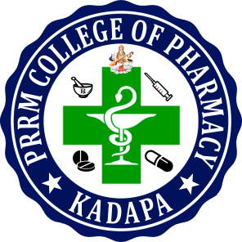

**CERTIFICATE**

This is to certify that the dissertation entitled **“ANALYTICAL METHOD DEVELOPMENT AND VALIDATION FOR SIMULTANEOUS ESTIMATION OF ROSUVASTATIN AND FENOFIBRATE IN TABLET DOSAGE FORM BY USING RP-HPLC METHOD”** that is being submitted by **Mrs. NAGINENI MANASA (15441S0706)** in partial fulfillment for the award of the degree of Master of Pharmacy in Pharmaceutical analysis to the Jawaharlal Nehru technical university Anantapur, Anathapuramu-515 002

It is a record of bonafied work carried out by her at our institution.

**Principal**

**Dr. K. RAVINDRA REDDY**

**M.Pharm.,Ph.D**

**Viva Voce Examination Held on:____________________**

**Internal Examiner External Examiner**